**Step by Step guide to install Jenkins on Amazon Linux.**

[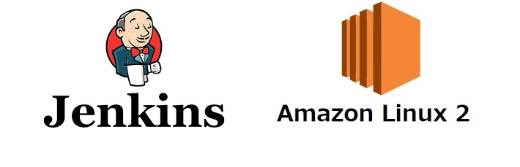](https://user-images.githubusercontent.com/119833411/241403167-c18c66fb-7b35-4c87-9bc5-ec7bd403062d.jpg)

**Prerequisites:**

**Minimum hardware requirements:**

* 256 MB of RAM Enough for doing proof of concept (POC).
* 1 GB of drive space (although 10 GB is a recommended minimum if running Jenkins as a Docker container) **Recommended hardware configuration for a small team:**
* 4 GB+ of RAM.
* 50 GB+ of drive space. **Software requirements:**
* Jenkins require Java-11 or later versions.
* Open Port.No 8080 in EC2-security group. (8080 is Default port of Jenkins)

**Launch an Amazon Linux EC2 instance.**

* instance-type: t2.micro

**Download Jenkins.**

Go to Jenkins Download page:-<https://www.jenkins.io/download/>

**Select LTS** [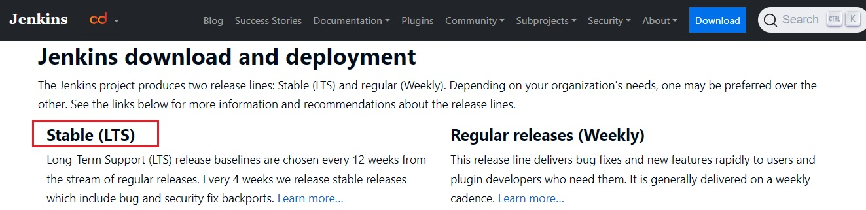](https://user-images.githubusercontent.com/119833411/241405049-445e50d6-8e15-42b3-9de7-899fa903b338.jpg)

**Select Red Hat/Fedora/Alma/Rocky/CentOS** [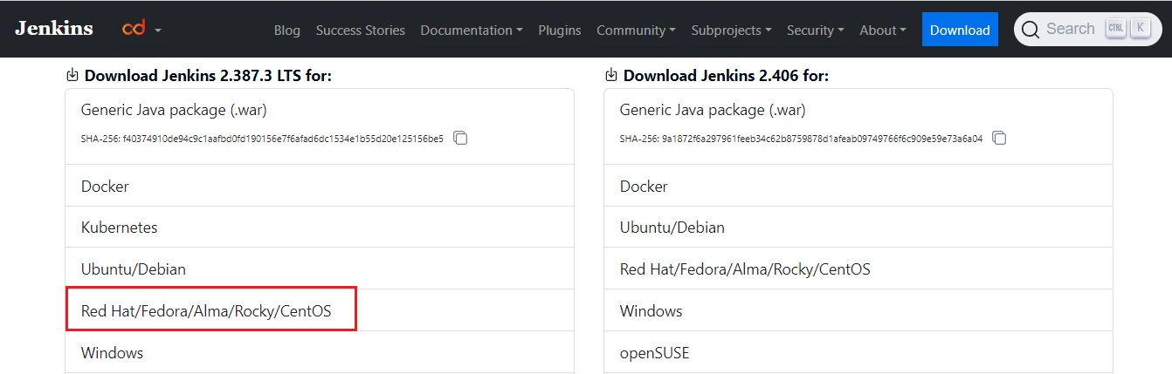](https://user-images.githubusercontent.com/119833411/241405139-8bf4fff6-7b4a-45b0-8066-4a09645b00ea.jpg) **You will see following command** [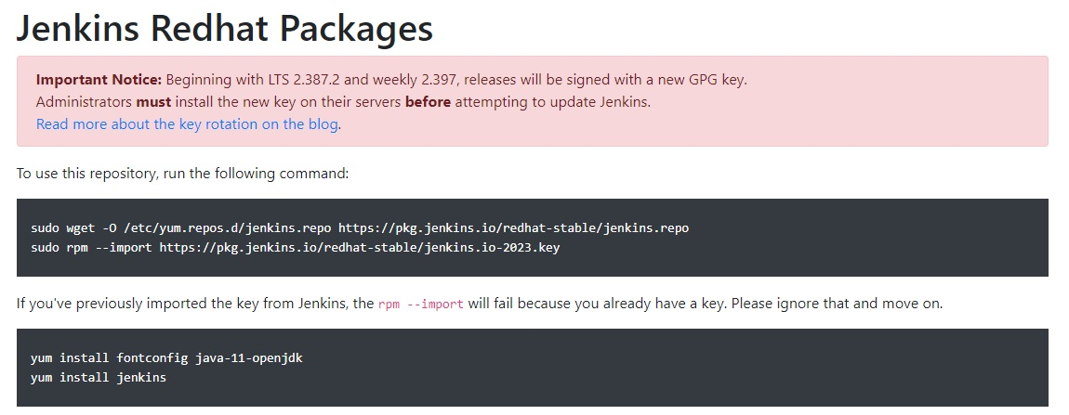](https://user-images.githubusercontent.com/119833411/241405814-3f643c95-1cc1-4c60-adf2-0a2cac019b7e.jpg)

**Connect to instance and execute following commands.**

# Become a root

sudo su -

# Jenkins repo is added to yum.repos.d

sudo wget -O /etc/yum.repos.d/jenkins.repo https://pkg.jenkins.io/redhat-stable/jenkins.repo

# Import key from Jenkins

sudo rpm --import https://pkg.jenkins.io/redhat-stable/jenkins.io-2023.key

# Install Java-11

amazon-linux-extras install java-openjdk11 -y

# Install Jenkins

yum install jenkins -y

**Start Jenkins.**

# Become a root, no need to execute if you are alread root.

sudo su -

# You can enable the Jenkins service to start at boot with the command:

systemctl enable jenkins

# You can start the Jenkins service with the command:

systemctl start jenkins

# You can check the status of the Jenkins service using the command:

systemctl status jenkins

**Open Web-Browser and access jenkins on port 8080.**

http://<Public-IPv4-address>:8080/

**You should see the following page.**

[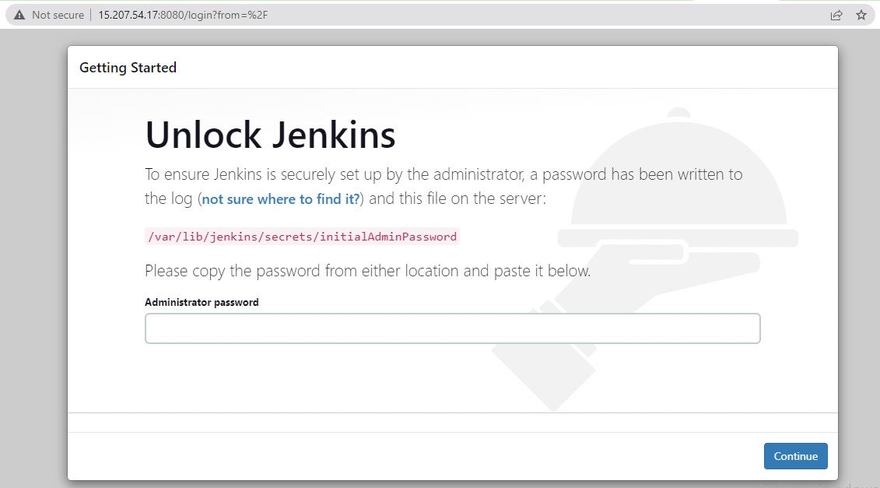](https://user-images.githubusercontent.com/119833411/241408010-caf9ff80-dcc9-4c64-aa23-0241db676689.jpg)

cat /var/lib/jenkins/secrets/initialAdminPassword

# you will get the password.

[](https://user-images.githubusercontent.com/119833411/241408673-70f1a2bc-7792-4936-84c6-34f894cc8e5e.jpg)

**Copy the Password and past in Web-Browser then press continue.**

[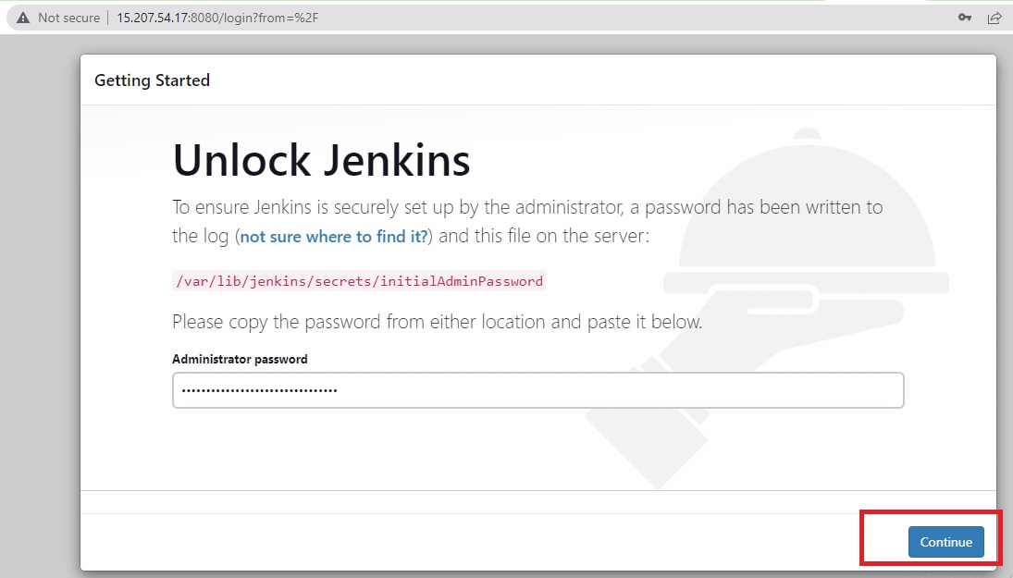](https://user-images.githubusercontent.com/119833411/241408735-fff1bd5c-6a39-483a-80e8-70a9085af78b.jpg)

**Go with Install Suggested Plugins.** [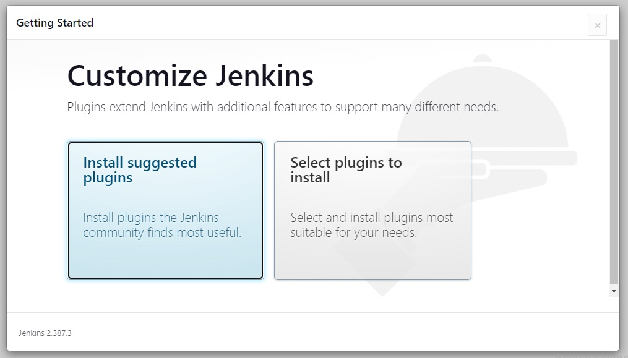](https://user-images.githubusercontent.com/119833411/241409217-49994812-ded3-4dcd-be1c-aa7a47478c64.jpg)

**Suggested Plugins will start downloading.** [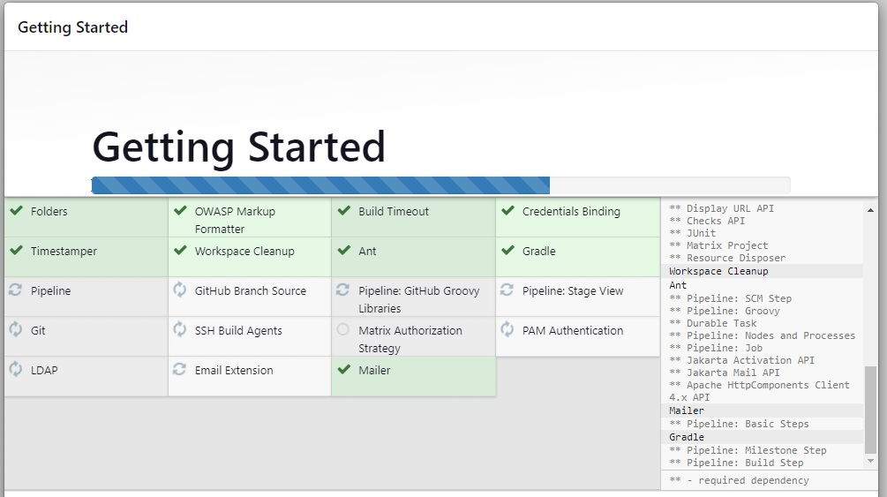](https://user-images.githubusercontent.com/119833411/241409495-d0ddb512-9384-4735-8d0b-530f07e229de.jpg)

**Fill the details and click save and continue.** [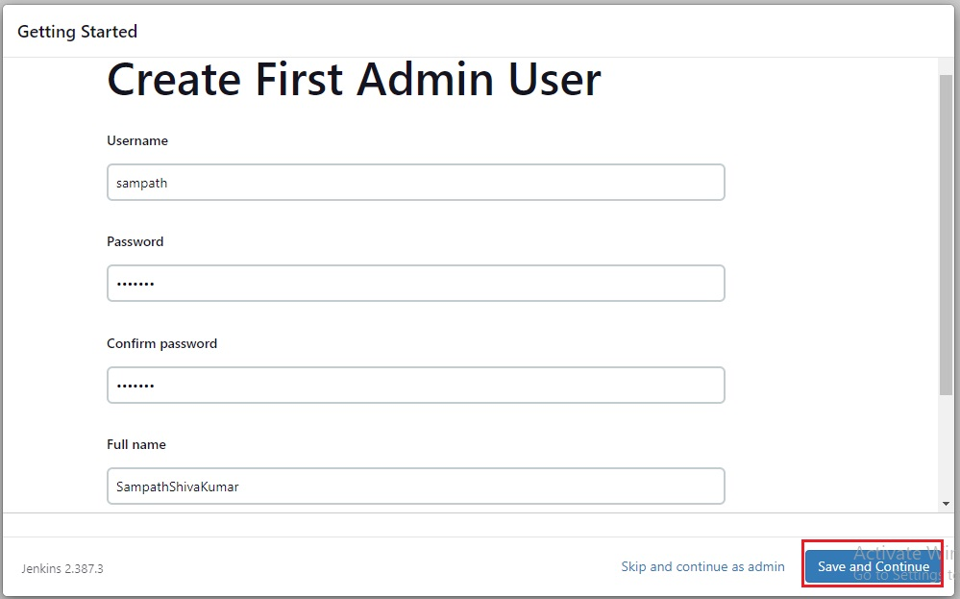](https://user-images.githubusercontent.com/119833411/241409915-064e078d-35c0-486e-afa0-e7c068ec7fb9.jpg)

**Click on Save and Finish.** [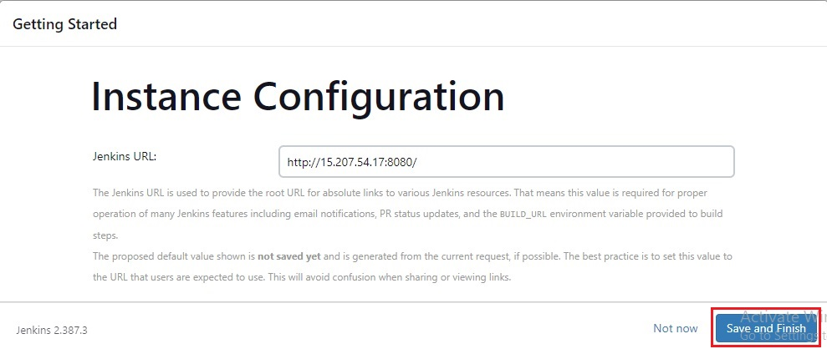](https://user-images.githubusercontent.com/119833411/241410580-e8630d51-e21e-4cd4-a078-45b7ae57f21a.jpg)

**Jenkins is ready click on start using Jenkins** [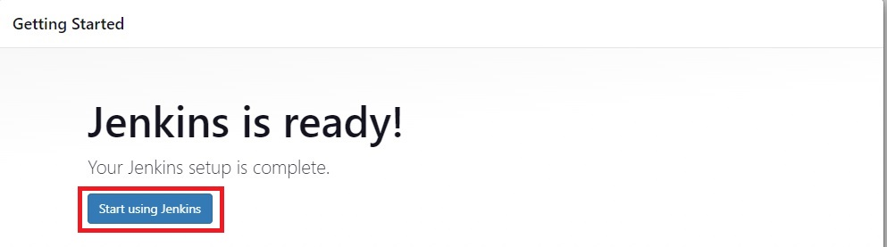](https://user-images.githubusercontent.com/119833411/241410588-70a0b2fe-7807-4a9b-84e1-8fa1eba101a9.jpg)

**Jenkins is successfully installed** [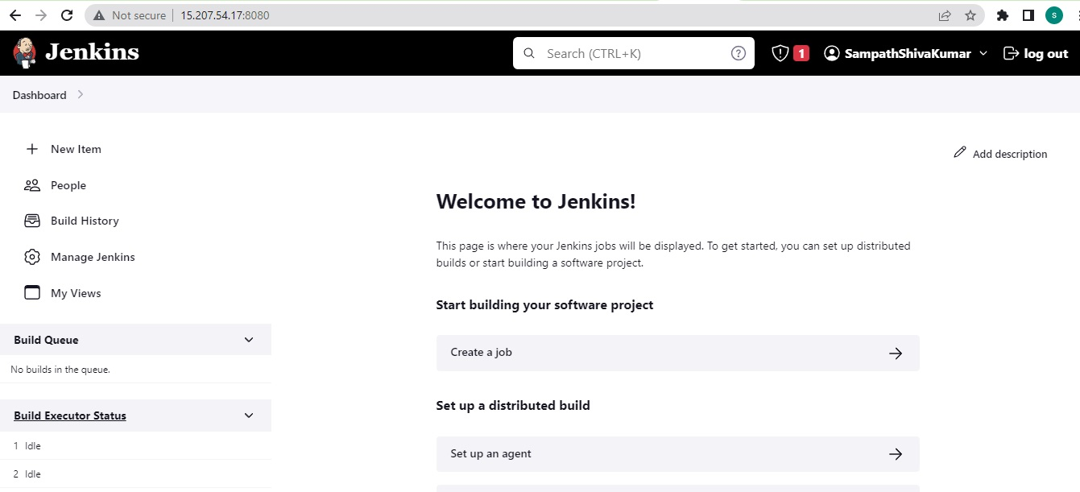](https://user-images.githubusercontent.com/119833411/241410684-376c06df-ca86-4b54-a5cd-4c22f6075cbc.jpg)

**Thank you for reading this post!**